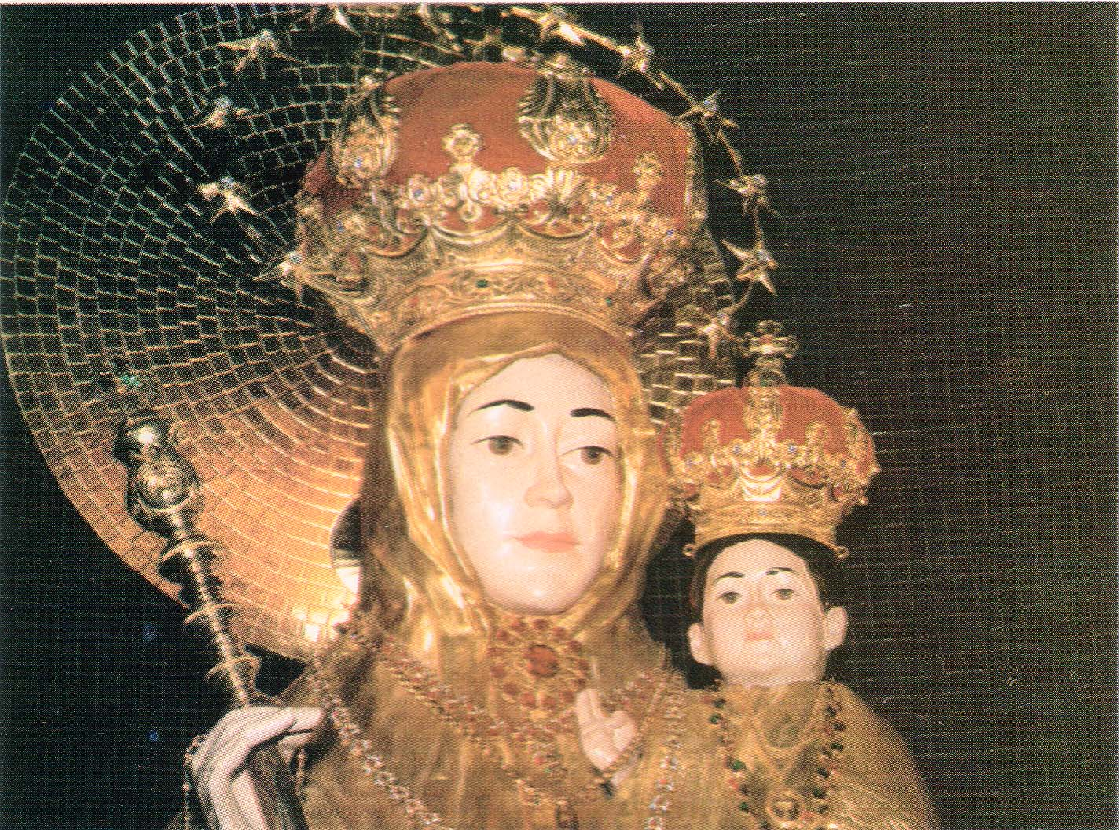
MOTHER OF MIRACLES (MOM)
13128 Brushwood Way, Potomac, MD 20854
Email: PraymolV@comcast.net, WEBSITE:www.motherofmiraclesdc.org

TO:

Perpetual Novena Services are held Every Saturday

All Saturdays: | Rosary & Novena 4:30pm
First Saturday: | Rosary followed by Mass & Novena

Next year, Mother of Miracles Celebration will be held on Saturday, May 25th, 2019

Directions from Virginia and the South

Take Route 66 East to Constitution Avenue in Washington. Travel east on Constitution Avenue to Louisiana Avenue. Turn left onto Louisiana Avenue. Travel two blocks and turn left onto North Capitol Street. Continue on North Capitol Street to Michigan Avenue. Turn right onto Michigan Avenue. The Basilica is four blocks east on the left. (400 Michigan Ave NE, Washington DC 20017-1565)

Directions from Maryland and the North

Take Interstate 95 South onto Route 495 west( Capital Beltway ) toward Silver Spring. Take Exit 28B towards Takoma Park onto New Hampshire Avenue (Route 650 south). Continue on New Hampshire Ave to North Capital Street. Turn left onto North Capitol St. Continue on North Capital St. to Michigan Ave. Take a left on Michigan Ave. The Basilica is four blocks east on the left. (400 Michigan Ave, NE, Washington DC 20017-1565)

Those who wish to include the children and sick please send their names to:-
Mother of Miracles (MOM), 13128 Brushwood Way, Potomac, MD 20854
Or
Email to: praymolv@comcast.net
Your Name and Address  Name:______________________________  Address:_____________________________  Email:______________________________  Names of the Children | Names of the Sick
NINETEENTH ANNUAL CELEBRATION OF MOTHER OF MIRACLES (MOM)

MOTHER OF MIRACLES
Our Lady of Good Health

Visit us at: www.motherofmiraclesdc.org
Email us at: PraymolV@comcast.net
HEALING MASS, BLESSING OF THE SICK &
THE CHILDREN to be held on MAY 26th, 2018

Dear Friends,

We are happy to announce The Nineteenth Annual Healing Mass and Celebration to honor Our Lady of Good Health to be held on Saturday May 26th, 2018 in the Crypt Church of the Basilica of the National Shrine of the Immaculate Conception, Washington D. C.

To perpetuate the devotion to Our Mother we get together for Rosary and Novena every Saturday at 4:30pm in the Oratory of Our Lady of Good Health, Vailankanni, in the Crypt Church. In addition, on the first Saturday of the month there will be a mass in honor of Our Lady.

PROGRAM

12:30pm  1.15pm | Assemble in the Mary’s Garden  Procession to The Crypt Church
1.45pm | Introduction – Rev. Fr. Binoy Akkalayil, O.SS.T Master of Ceremonies –Karen Kurian
1.50pm | Rosary – By Children
2.15pm | Addressing the Children – Rev. Fr. David Verghese Kannarkat
 | Special prayers and Blessing of the children
 | Distribution of Mother of Miracles Pins and Rosary to the children
2.45pm | Healing Mass
Main Celebrant: His Excellency Most Rev. Mark E. Brennan, DD
Auxiliary Bishop of Baltimore
 | Final Blessing and Blessing of the sick
4.35pm | Procession to the Oratory
 | Presentation of the children’s names
4:40pm | MUKHADARSHANAM: Exposition of the statue of Our Lady of Good Health  Novena
5:00pm | Reception – Caldwell Hall
Confessions will be heard from 12:30pm to 2:30pm

Please contact any of the following people for Special intentions, Mass offering and Petitions or if you’d like to participate in any way:

Praymol Varghese, MD (301) 990 0540 Sulocha Fernandopulle,MD (301) 328 5872
Molly Vettickal, VA | (703) 698 5118 | David | Kalampanyil, MD | (443) 741 1251
Thomas P.Thomas,NY | (917) 499 8080 |  | George Patteril,NY | (914) 963 2959
Anna Sebastian, NY  Boby Augustine, MD  Shine Mathew, MD  Sherly Abraham, MD | (201) 529 4694  (301) 515 1678  (301) 262 3952  (301) 256 4759 |  | Anson Antony,MD  Rosey Antony,IL  Maria Thottukadavil  Mary Bastian, VA | (443)325 0168  (309) 444 979)  (973) 699 7825  (703) 361 3714

